**QUESTION 1**

1. Create the table named EMPLOYEE, insert the employee details below and assign a primary

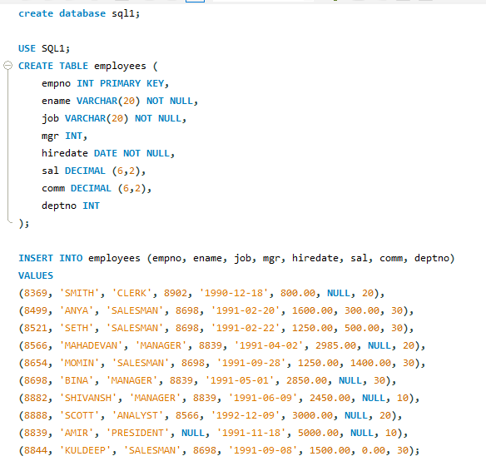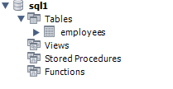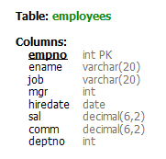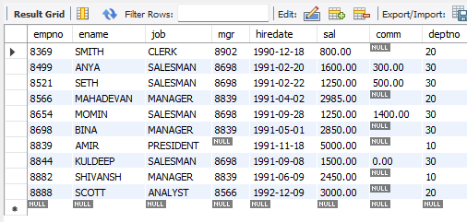

1. 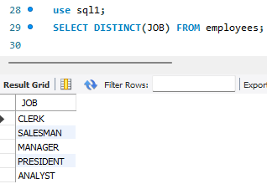Return only the jobs from the table. List them only once (1).
2. Return all records from the table. (2)

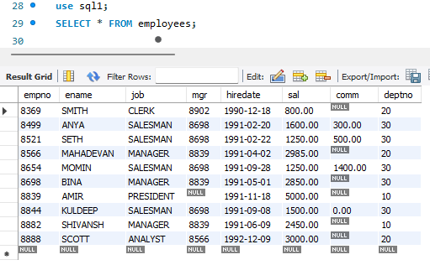

1. Return employee name and salary of employees whose salaries are greater than or equal to 2200. (2)

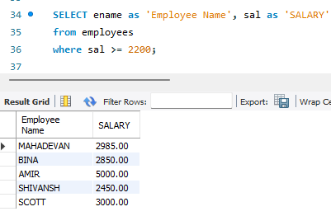

1. Return employee name and salary of those employees who do not have their salary in the range of 2500 to 4000. (2)

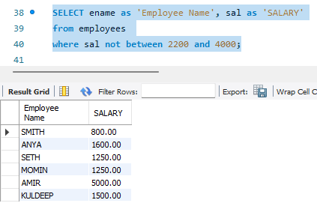

1. Return employee name whose name contains “I” as third character. (2)

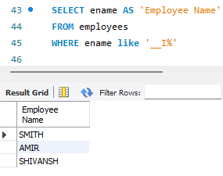

1. Return employee name whose name contains” M” as first and “H” as third character. (2)

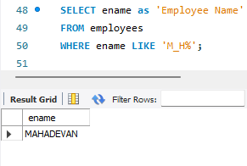

1. Count the number of employees in each department, with the department number along with the employee count. (2)

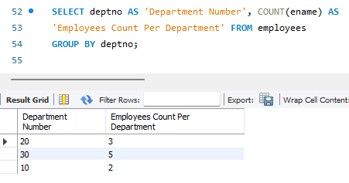

1. Return employee name and hire dates of employees hired after 1991-01-01. (2)

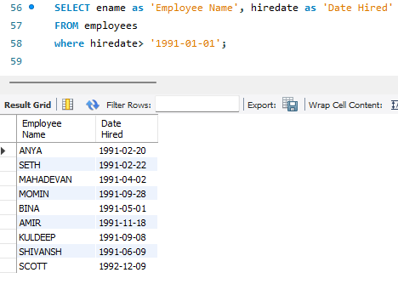

1. Calculate the average salary of all employees. (2)

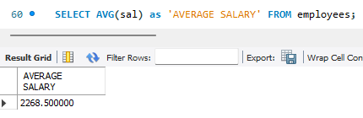

**QUESTION 2**

1. Create the following tables and name them student and project respectively. (2)

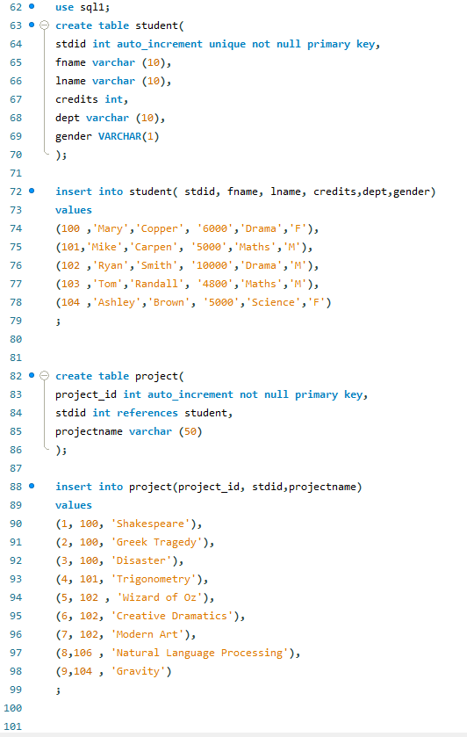

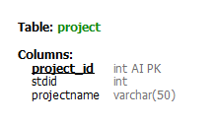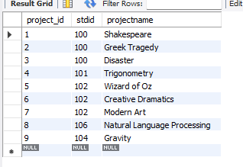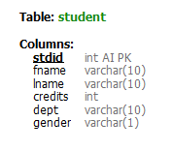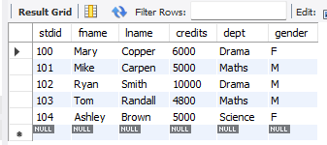

1. Return the project names along with the corresponding student details (first name, last name) for all projects. (2)

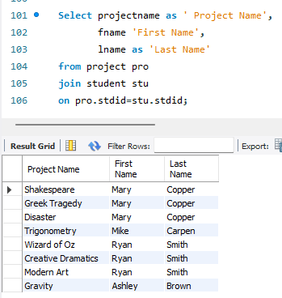

1. Return the project names and the corresponding student details (first name, last name) for projects assigned to students in the "Maths" department. (2)

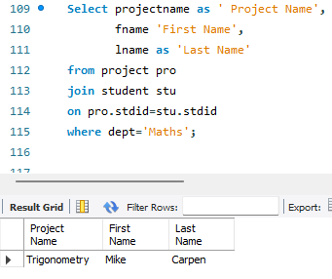

1. Return all students along with the project names (if any) they are assigned to. (2)

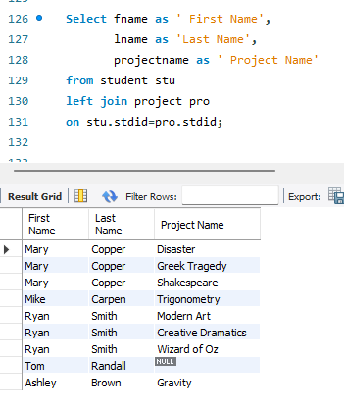

1. Return all students and the project names (if any) they are assigned to, but only for the students in the "Drama" department.

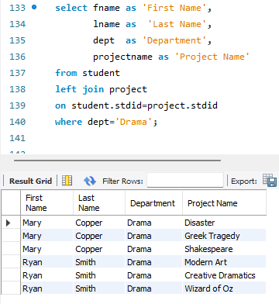

1. 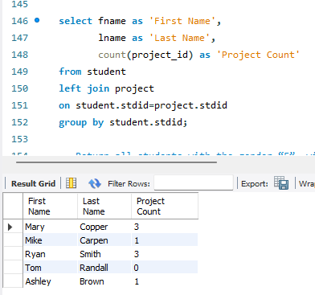 Return the total number of projects each student is assigned to, along with their details (first name, last name). (2)
2. Return all students with the gender “F”, with their total credits (2)

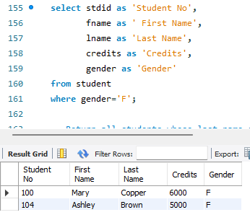

1. Return all students whose last name ends with "pen". (2)

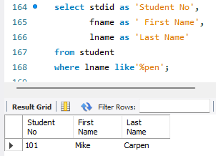

1. Return the names of students with the gender “M”, with more than 4999 credits, sorted alphabetically by their first names. (2)

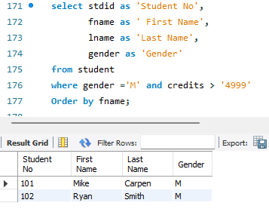

1. Return all students' details and sort them based on their credits in descending order. (2)

